**Py 4 Homework – Team 4**

**Team Hand Tracking**

Output:

n b k new_term

8 4 0 448

8 4 0 128

6 4 1 324

**Task 1:**

**Part A:**

1. file = open(‘test.txt’,’r’), file = open(‘test.txt’,’w’), file = open(‘test.txt’,’r+’) respectively
2. file.write(‘text’)
3. file.write(string) file.write(str(integer)) file.write(str(round(float,3)))

**Part B:**

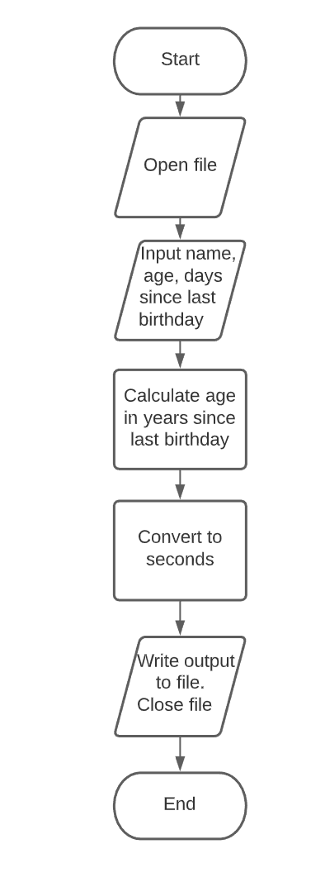

**Task 3**

**Part A:**

1) str = file.readline()

2) use readline() and use int() or float() to convert the readline() string. You must convert because readline() returns a string

3) file.readlines() would take the file and split it into a list of lines immediately